**Aniya Adil (047)**

**FIZZ-BUZZ GAME:**

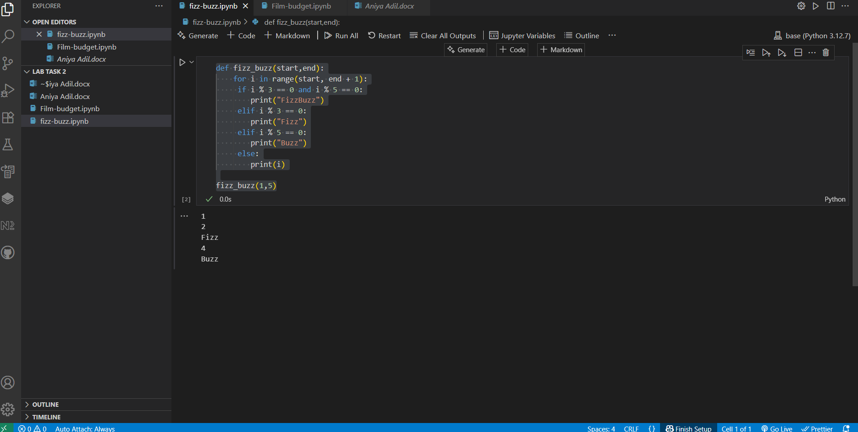

Suppose we define a function fizz buzz and give them 2 parameters (start, end)

After this give them range start and end but in end range, we add 1 because if we put range (1,5) it will start from 1 but doesn’t end at 5 it gives us numbers before the end range value i.e. :(1,2,3,4) **5 is not include**.so if we want to get range from (1,5) we add end+1.

. If the number is divisible by 3, print "Fizz".

. If the number is divisible by 5, print "Buzz".

. If the number is divisible by both 3 and 5, print "Fizz Buzz".

. Otherwise, print the number itself.

**Explanation:**

* **1:** Not divisible by 3 or 5 → prints 1
* **2:** Not divisible by 3 or 5 → prints 2
* **3:** Divisible by 3 → prints Fizz
* **4:** Not divisible by 3 or 5 → prints 4
* **5:** Divisible by 5 → prints Buzz